1. Create one vpc in N.virginia region.

🡪

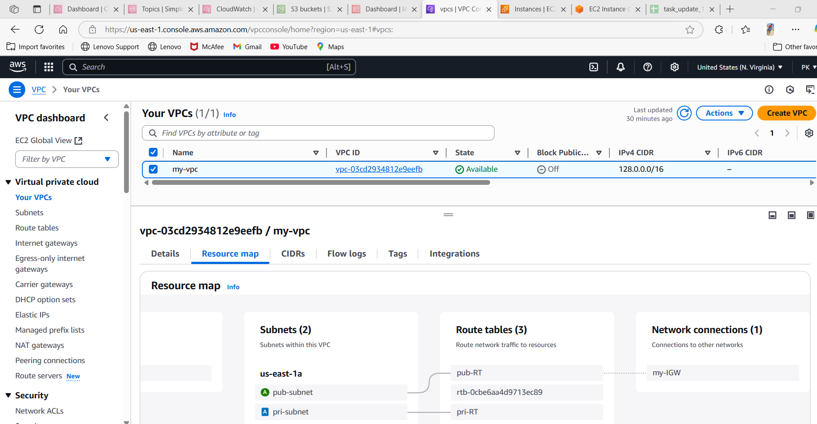  
2) Create two subnets.  
   One Public subnet and one private subnet.

🡪



3) Provide the IGW to the vpc.

🡪

  
4) Create One public RT and one private RT.

🡪



5) Deploy NAT gateway on public subnet and attach the NAT gatewat to private subnet.

🡪create NAT gateway and attached to pri-RT

🡪go to route tables—select pri-RT—routes—edit routes—add route—0.0.0.0/nat gateway—save.

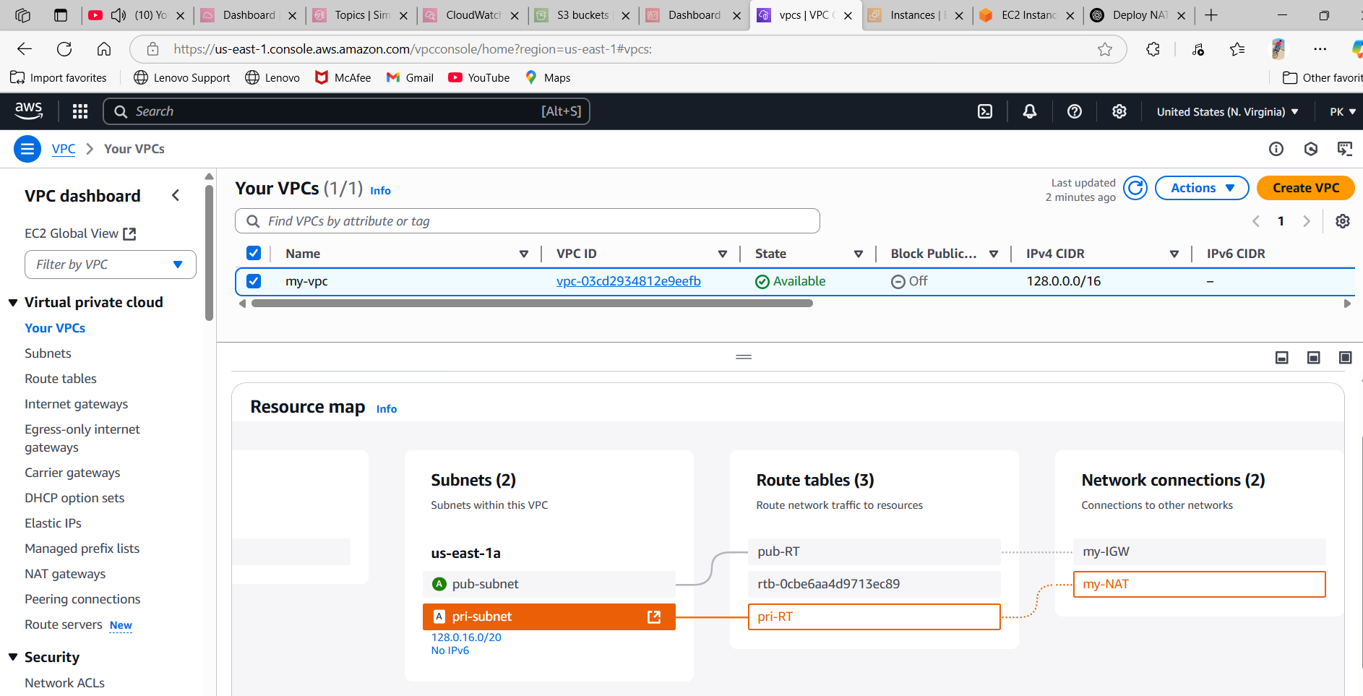

6) Create Two instances,one in public subnet and one in private subnet.

🡪

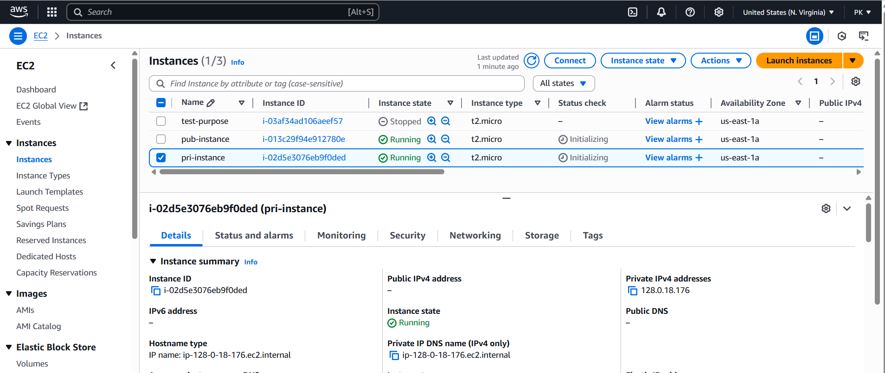

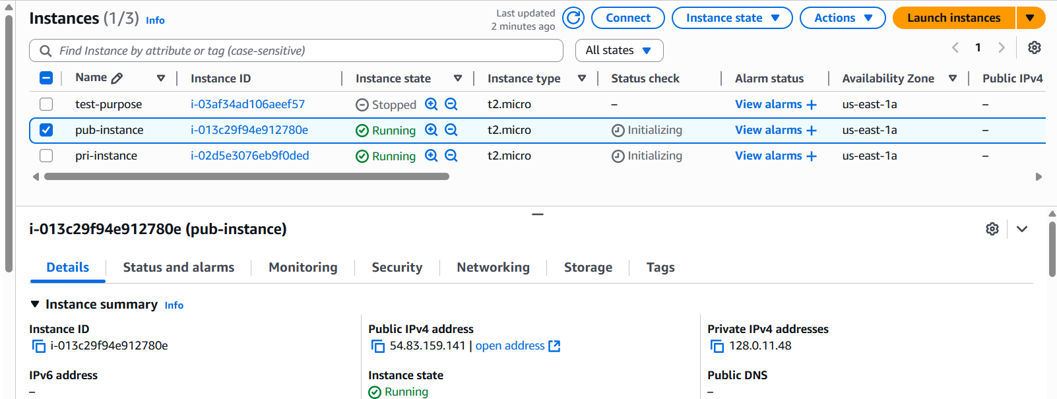

7) Deploy Apache server on both the ec2 instances with sample index.html file.

🡪

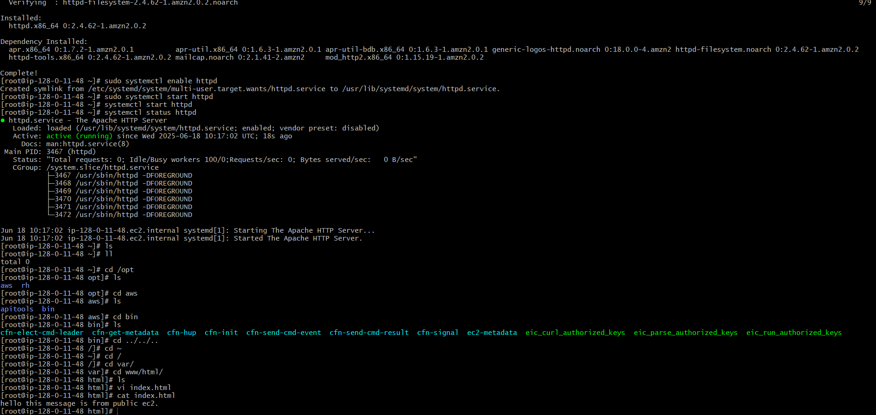



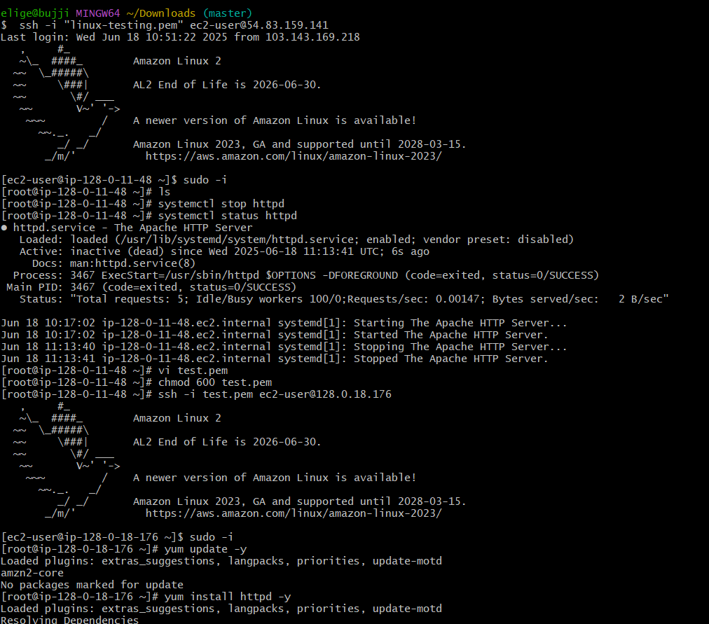

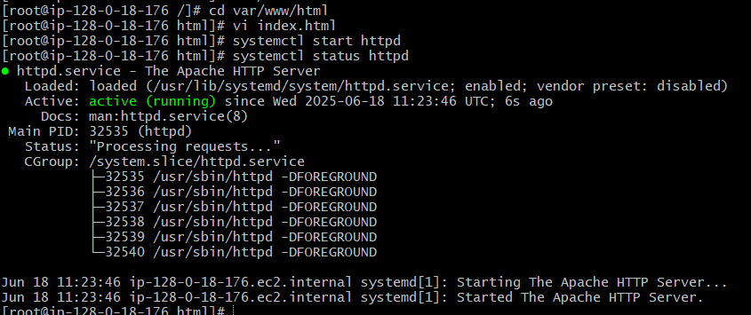

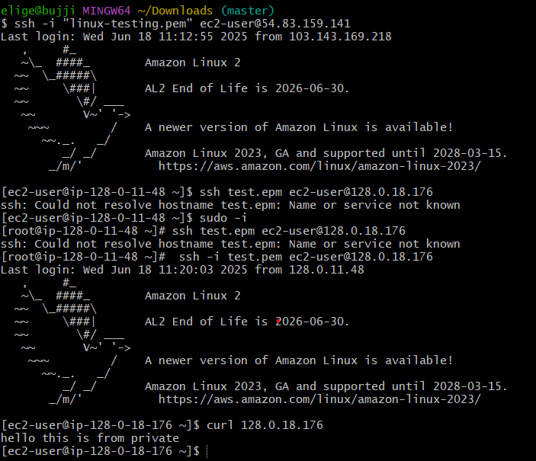  
8) Create one application load balancer and attach the load balancer to both the ec2 instances.

🡪go to ec2—load balancer—create—give details—create one target group attach to load balancer—create load balancer.

🡪attach instances.

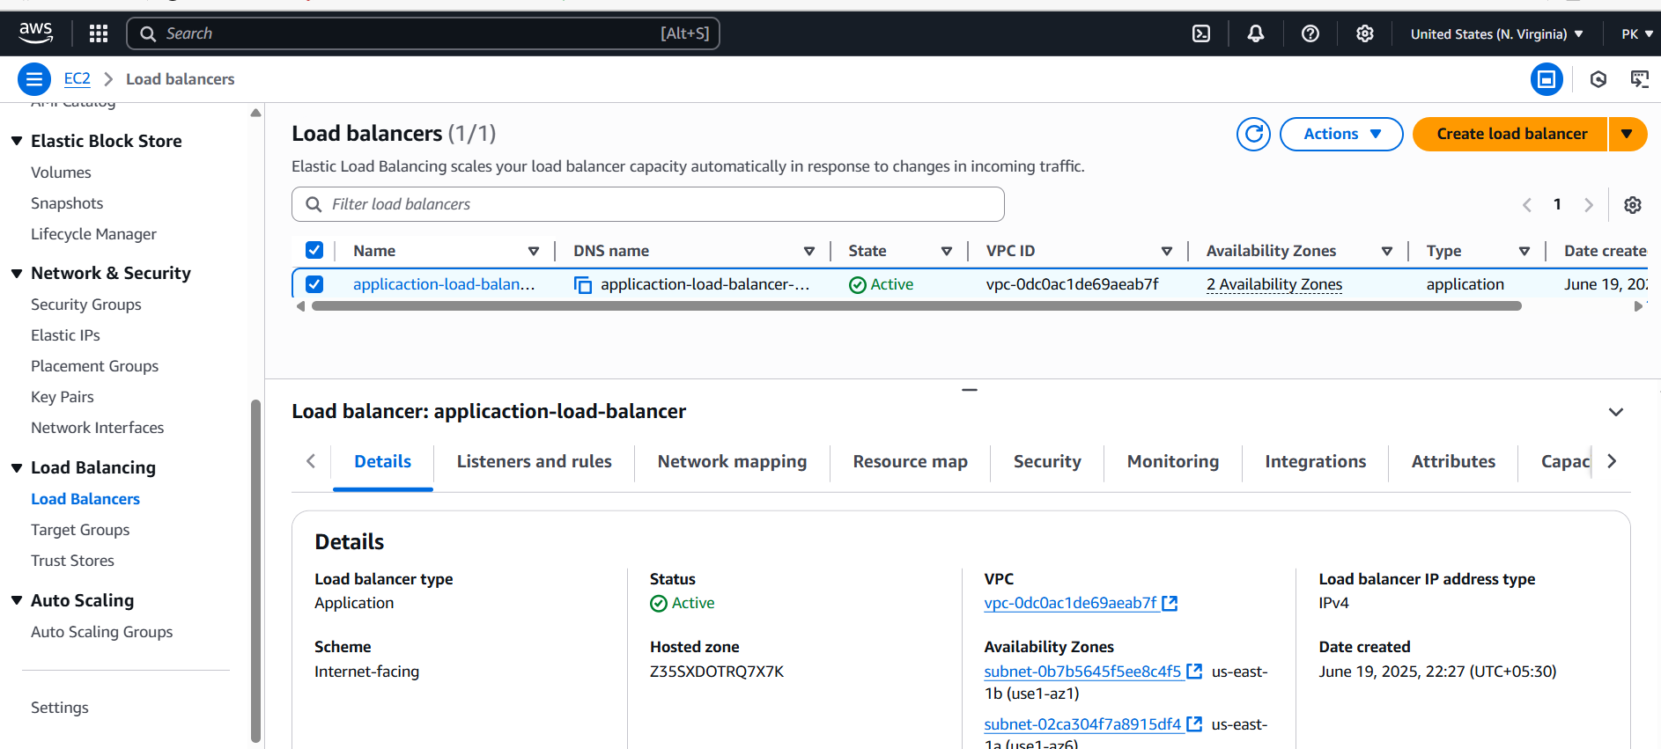

9) Store Application load balancer logs to s3.  
🡪

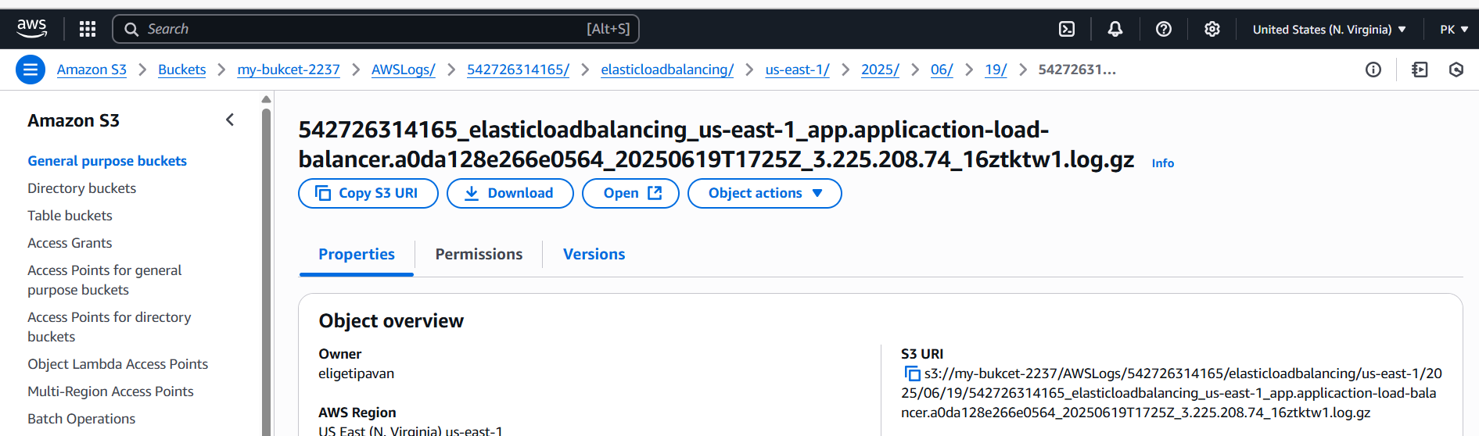

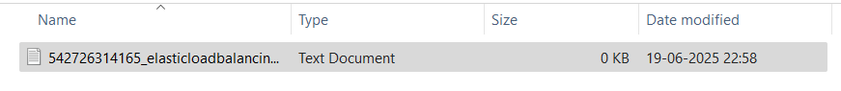

10) Store the vpc flow logs to cloudwtach group.

🡪create one policy.

🡪create role—custom trust policy—attach policy—create.

🡪go to cloudwatch—create flow log.

🡪go to vpc—select vpc—actions—create flow log—filter(All)—destination(send to cloud watch)—log group(select the created log)—attch IAM role—create.

🡪after some time you will see some logs in cloud watch log group(streams).

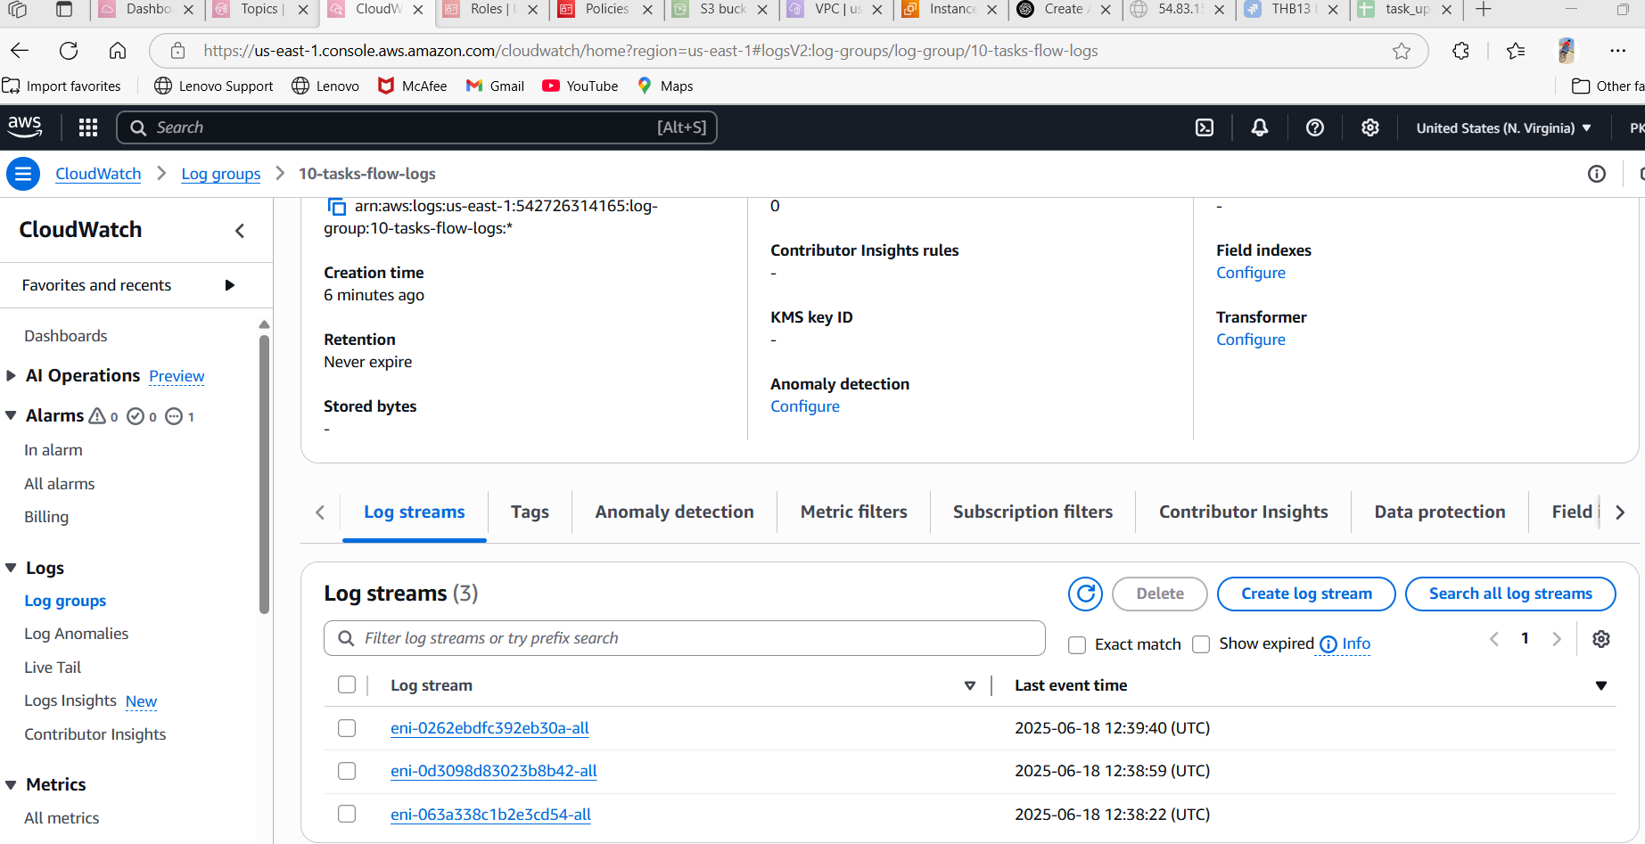  
11) Create Monitoring Dashboards to monitor cpu utilization and to monitor apache service.

🡪launch one ec2 with IAM role(ec2-server-policy—ec2fullaccess & cloudwatchAgentserverpolicy)—connect to ec2 server—install httpd—systemctl enable httpd—systemctl start httpd—systemctl status httpd.

🡪create bash script(apache-monitor.sh—edit script)—chmod +x or 755 apache-monitor.sh

🡪cronjob -e-- \* \* \* \* \* /apache-monitor.sh

🡪go to cloud watch-dashboard—create 2 dashboard(ec2-monitor & httpd-monitor)—select—number—select custom name space(apache & ec2—per instance—instance(cpu utilization))—apache service—save.

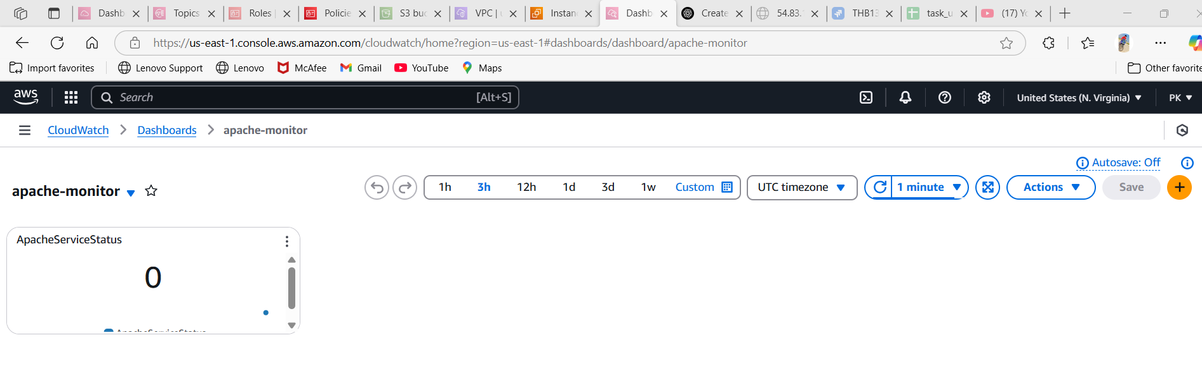

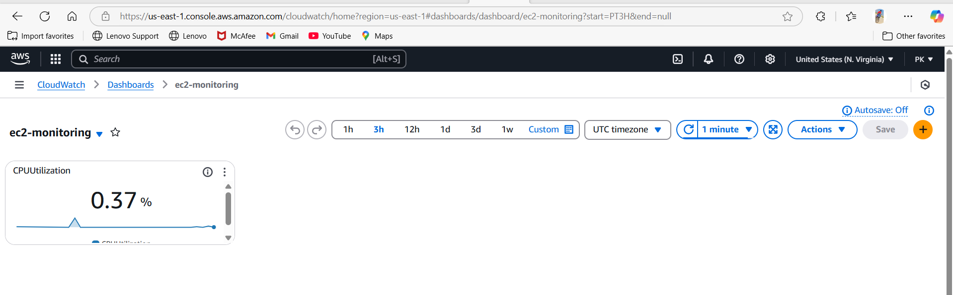

12) CPU utilizationis more than 70% then it should triggere Autoscaling and launch new instance

🡪

